First Time Implementation:
A Path to Success
A Oxcyon Centralpoint Practice Whitepaper
The Challenges for First Time Centralpoint Implementation
Overcoming Stigma
Recent data shows that the need for large scale enterprise portal solutions has proliferated in the industry amongst large and small business enterprises alike. More than 75% of Fortune 100 companies have started using some type of portal technology in which to organize and centralize their disparate data. More than 70% of these implementations have been deemed unsuccessful due to limitations in interoperability, integration and UX/UI issues for users.
Most of Oxcyon’s clients come this 70%, which means you are likely trying it again, and you might be a little skeptical. First, remember that Centralpoint was developed to combat this problem specifically. It’s centralized architecture is designed to streamline the flow of information within your enterprise; in contrast to the older fragmented approach of cobbling together different silos of information. Said another way, you could be (if you are amongst this 70%) already frustrated from your experience with your last vendor.
Take a moment to consider the genesis of Oxcyon and its Centralpoint platform. The company was founded in 2001, in direct response to problems organizations had with other enterprise solutions. Oxcyon set out to harmonize the many information types, across your many users including the development of robust data migration tools to help you make the transition. Said another way….it is important for your users to realize that Centralpoint is not simply a new version of an old technology. A renewed sense of vendor faith and confidence will be needed to overcome stigmas with past technology vendors, and to think through some of their issues…this time, with a good chance to solve them.
Centralpoint's wide appeal and apparent simplicity sometimes lull users into a false sense of security. They often jump into full implementation cycle without first adequately understanding business requirements, governance issues and infrastructure requirements. Users start with a simple out of the box implementation on “as is” basis because they find the experience interesting, and rather gratifying due to initial, short term (low hanging fruit) successes.
This situation can be readily prevented by following some simple steps and the full power and flexibility of Centralpoint can be unleashed. Our experience has been that time spent on initial planning, implementation and iterative deployment approach under the guidance of experienced personnel can help avoid these pitfalls. Organizations that follow these simple processes can realize the promised benefits of Centralpoint in all the six areas of its functionality. IEEE has studied the importance of planning early in the project, and as Oxcyon production management is known to say, the larger your enterprise, the more important it is to ‘Measure three times, before cutting once’.
Architecture: A Top Down Approach
Centralpoint provides market readiness including over 220 out of the box tools (modules) empowering each client , whether hosted on premise or in the cloud, with a cascading framework to manage Development, Staging and live Production projects.
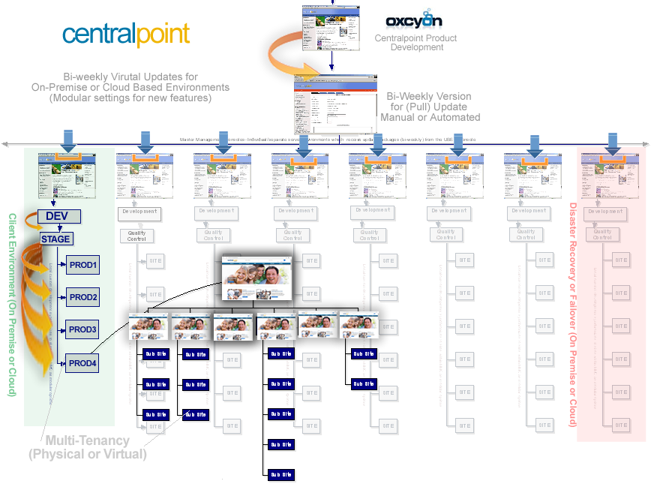
Figure 1. Oxcyon’s Centralpoint architecture which updates clients hosted on premise or in the cloud
Centralpoint provides market readiness upon deployment from its Master Server installation, including Development, QC (Staging), and Live Production environments, which support automated synchronization of modular functions, content & associated media files. It also supports the consideration for disaster recovery and fault tolerance between disparate multi tenancy environments.
Preparing for your Install
Centralpoint can quickly and easily be deployed via its installation wizard. This process can take anywhere between (as fast as) 15 minutes to one hour. This time frame depends on how thoroughly you have read the server preparation checklist ahead of the installation. We recommend you step through this checklist thoroughly to guarantee a smooth and fast installation, with no aggravation.

The Centralpoint (Master) Server
The Centralpoint Server (aka Master) allows for multi tenancy between Development, QC (Staging) and numerous production environments, including the ability to schedule updates (or synchronizations) between these environments (includes functions, content and media assets).
The Centralpoint server supports many scheduled tasks such as database backups, maintenance routines, and even Health Monitors which monitor and report on the health (aka performance) of each of your many environments (Development, QC (Staging) and Production Sites.
This server is listening for new updates from Oxcyon, and when updated (manually or by scheduled task (automatically) the server will pull updates from Centralpoint’s latest release, making new functions available as options which can be activated by the administrator.
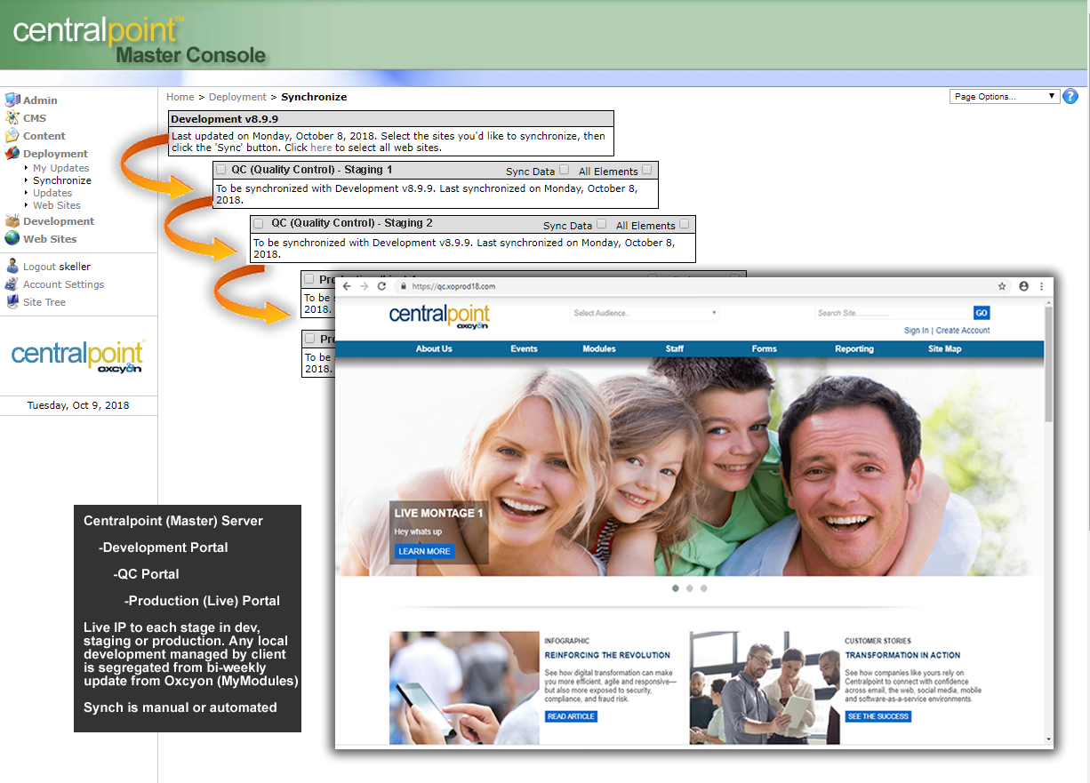
Figure 2. Centralpoint (Master) Server control over Development, Staging and production (live) sites.
With the right architecture in place, it is now about familiarizing yourself with the development portal, Centralpoint’s many functions, and then to better understand how these functions fit neatly into the vision of your project.
Phase 1: Vision
Centralpoint functionality can be segmented into six major buckets, namely, collaboration, portal, search, content management, business forms and business intelligence.
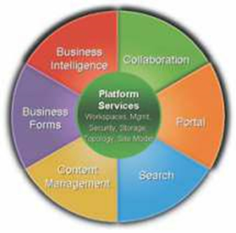
Figure 3. Breaking out your vision into six primary categories
By compartmentalizing each business requirement into one or more of these buckets, one can create a project road map that includes an overall approach, design, short and long term business goals, and a prioritized project implementation plan to encompass the business vision for Centralpoint. For instance, an organization such as an educational institution may get the most “bang for the buck” by implementing a teacher training management portal or a simple admissions evaluation portal for prospective candidates. A sales driven organization may need a BI or dashboard and reporting feature initially. A legal firm may be best served by prioritizing document management functions. Hence the visioning exercise becomes very important to guide the implementation priorities of Centralpoint.
A crucial step in visioning is a focused discussion with a clear agenda involving a representative group of people consisting of key stake holders, end users and the IT team. The discussion should elicit both near term and future requirements. These could include:
- Target Audience - internal, geographically dispersed and internet users
  - Who will it serve (role or types of users) within which channels
- Organization structure - departments, inter-departmental interactions and roles
- Depth and breadth of existing data and future growth, documents, other information systems
- Corporate security model
- Branding needs
- Knowledge & Information Needs
- Taxonomy, Metadata & Search
- Business Intelligence & Reporting
These requirements drive the necessary infrastructure recommendations, high level architecture design and the Centralpoint site hierarchy that form the foundation on which future development can be done.
Vision helps in bringing out the enterprise requirements with a long term focus in mind. This results in a scalable deployment plan and helps visualize the reusable components to be developed in the initial stages and avoids rework at a later stage.

Phase 2: Pilot Implementation Framework for a Focus Group
We describe a 3 phased approach which is particularly suitable for a “First Time Centralpoint Implementation” and it can also be used as a general methodology for any Centralpoint projects as such. First resist an urge to jump right into a full blown implementation just because it seems easy. By following a relatively simple framework such as shown below, users can segment the project into more manageable chunks and incrementally build on these small successes.
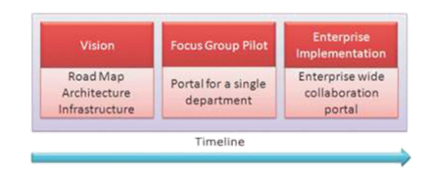
Figure 4: Phased Approach for First Time Implementation of Centralpoint in an Enterprise
The Vision exercise should identify a specific group of end users who share a common function in the enterprise such as a department or a business goal. This group generally has relatively better defined, pronounced needs that can be taken up for the pilot implementation for the organization. Since this is the first such project, an iterative and collaborative approach is preferred to maintain flexibility and support for the project. Since success of this pilot will define the subsequent buy in from other groups, it is important to ensure that all issues are adequately addressed for smooth project execution and deployment. One should go the extra mile in ensuring that issues such as given below are addressed:
- User training and orientation for Centralpoint
- Documentation of business requirements and usage manuals
- Reviews and design mapping
- Post deployment user support and end user training
- How does it remedy the problems which Centralpoint was introduced to solve
- Capacity planning and infrastructure operations planning
The following diagram shows the framework that can be used as a guideline to help implement Centralpoint successfully for one pilot group. This can be easily replicated for other departments and Centralpoint can be extended across the enterprise successfully.

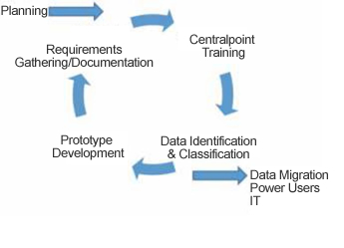
Figure 5 - Process for implementing Oxcyon Centralpoint with the first focus user group
This iterative process begins with planning that yields documented requirements, both functional and non-functional such as infrastructure, performance and security. Oxcyon provides a wide range of templates for documenting these requirements. These templates can be simplified to some degree and made more relevant for easy use on this pilot.
The users are then given basic training in the use of the Centralpoint tools, do's and don'ts and basic best practices. The end users have to be trained on the usage of the actual implementation, with special attention to the power users who in turn can assist the other users. The training has to be well structured and should adopt intuitive ways for it to be beneficial. E.g.: Multiple people can work together to initiate and complete a sample workflow feature rather than providing a demo on screen which can be very confusing.
Then the data to be populated into the portal is identified and classified. The migration tools are built and implemented, if needed. Once users have understood Centralpoint operations, they could actively participate in grouping, categorizing and mapping their existing information or data into Centralpoint features. This active role and involvement of the user group is very critical for the success of the project.
The implementation team should endeavor to meet end users' expectations with Centralpoint's out of the box features as much as possible, and refrain from custom coding. The tendency of end users to expect a custom developed application should be minimized. The users then use a prototype version of the portal (development or staging). They oﬀer feedback to the implementation team and this process undergoes a couple of iterations before launch for this group.
Centralpoint in the end must be seen as a service and not an application. Even though a third party Centralpoint services vendor may architect and implement the initial solution, it is the IT team or the end users who will own and manage the solution in the long run. Centralpoint is all about the six components described above which are services to the end users.
The IT team or the end users must be involved in all of the activities right from the start. They have to provided necessary training on the Centralpoint so as to enable them make informed decisions about security, implementing IT policies where required and administration of Centralpoint.
Phase 3: Replicate and Extend: Understanding the Enterprise
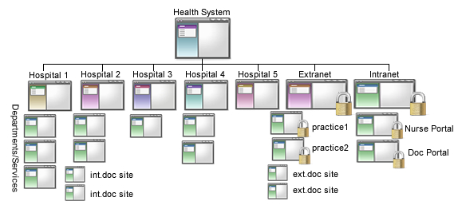
Figure 6. Maximizing Shared Service, by replicating solutions to other groups within the enterprise
Successful implementation for the focus group will promote further usage and propagate further adoption by other groups. Much of the processes and implementation can be generally replicated, data stores can be extended and shared and deployment can be spread across diﬀerent departments and geographies. The pilot will form the basis for further growth in terms of extensions and enhancements for the rest of the enterprise. Benefits include:
Easier addition of other portals to support diﬀerent functions
- Best practices from the initial implementations can help build better portals and improve productivity right from the start.
- Information silos across organizations can be avoided by design. Integration needs can be aggregated. Data and information duplication can be avoided.
- User training can be easily replicated and adoption can be faster
- The relatively small investment in defining and planning the process for the first implementation for a couple of departments yields massive returns over the long term.
Tips on How to process requests made by your end users. Your users will likely have a lot of ideas regarding improving the efficiencies of your enterprise. Oxcyon welcomes these new ideas, but ask you to filter each new request based upon the following criteria:
- Has any other user had the same issue?
- Are there any work arounds, or other methods to accomplish the same thing (OOTB)?
- Is this a change which will result in a savings of time?
- Is this a change which other users will find useful?
- If this request requires custom coding (by client or Oxcyon) is the time saved worth the expense of the custom development effort?
- How does this change impact the overall management of the enterprise moving forward?
- Does this change mean altering the way information is classified?
- Do you have a form in place to accept all incoming requests, so that they may be routed to someone in governance over the enterprise?
- Will there be a performance cost (in terms of page speed) for this request?
- How senior is the individual making the request, and if not, has it been shared with a more senior representative to have it pass any litmus test?
- Should this new request require consensus by other similar team members, before it is considered for implementation?

Oxcyon encourages new ideas from your team members and without them, the enterprise will not flourish. Oxcyon calls this ‘VOC’ (Voice of Customer), and not only do we depend on it to guide our overall development efforts for the product; you should too for the success of your enterprise.
This suggests that not all ideas are good ideas for the group. We encourage your welcome new ideas, whilst scrutinizing the impact on all users within the enterprise; governing consensus and the acceptance by all of your many enterprise users.
Getting a Handle on your Enterprise
To simplify Centralpoint, you may ask yourself three questions: What departments are we trying to communicate with, Who specifically within those departments, and What types of information do each of them need. Answering these three basic questions, will help you better understand Audiences, Styles, Roles, Modules, and Taxonomy. Information cascades from the ‘central point’ to these many constituencies, and in a variety of ways. The information cascades down through these many layers, to reach the individuals at the other end. Audiences are synonymous with Departments (or subsidiaries), Roles relate the specific job title of user, and taxonomy equates to the many different types of policies, news or events that they seek. Understanding these tiers is essential toward implementing Centralpoint easily. It also allows you to see how data may be collected ‘from’ these users (typically from forms or actions they take online), pooling the reporting upstream, by Audience, Role, and type of thing they are doing.
Information is a Two Way Street
Give some consideration before even getting started that this should not just be a one way communication (information you send to your users). It should also consider what information you will need ‘back’ from your users as they participate. Yes, this information is supposed to help them (your users) do their jobs better and faster; but it can also help you better serve them moving forward. Their demands online should be the primary focal point for new content creation. Responding to these ‘market demands’ suggest tracking some of these types below :
- User Activity (Clicks, Hits, Data entry, Ratings, Comments, Bookmarks, Keywords searched)
- Education Results: Who passed or failed which online courses, gauging their depth of knowledge
- Purchasing: What purchases have been made by which user
- Collaboration: Who is most active in terms of collaborating with others while online
- Contributions: Who has suggested more ideas than others
- Email Success: Who opened which email or alert sent and who didn’t
- Data Entry: Who entered in their reporting on time, and who didn’t
- Preferences: Who liked which information best and what is the consensus?
- Survey Results: What is the trending interests by your users?
- Search Trends: What are the highest terms being searched by each and all
- Empty Searches: What searches yielded no results, where are the dead ends?
- Natural Language: What terms and language are users using to find things?
- Frequently Asked Questions: Pay careful attention to the hits/clicks of each
Conclusion
A well planned iterative approach to implementation of Oxcyon Centralpoint can substantially increase user adoption, increase productivity and foster collaboration. On the other hand adhoc implementation by a “install license and forget” process can easily create disillusionment amongst users and make successful implementation diﬃcult thereafter.
The planned process could begin with demonstrating success with one Oxcyon Centralpoint portal with one group of users. This process could then be replicated in other departments. Replication fosters use of Centralpoint best practices and avoids rework and duplication. It also helps plan and manage budgets during implementation, improves productivity, reduces risks and makes the Centralpoint implementation successful.

